How to use SkinManager [v0.1.0b]

Preparation

1| Download the archive of skinmanager

2| Unzip it and it put it somewhere easy to access like your Desktop (not necessary)

Note: Don’t touch ‘_jre’ folder, just use the program (.exe)

Use

Execute ‘skinmanager.exe’

- The first time skinmanager is used, it will ask the game path (open local files of game from steam, copy the path from there and paste it):
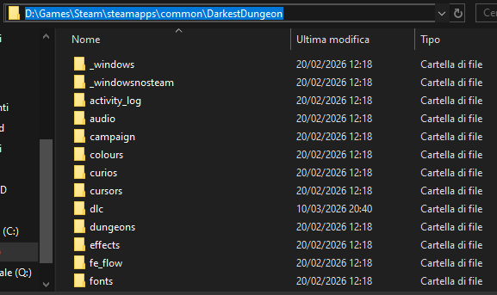(If you want to input the path again, delete config.txt which is generated after adding the path, then close and re-open the manager)

- After adding the path, the menu will become available, which is divided in 4 sections

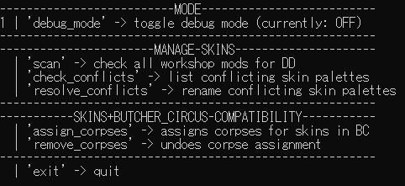
Section MODE:only for toggling debug_mode

- debug_mode -> toggle for seeing / not seeing debug logs (debug logs specify in-depth what happens)

Section MANAGE SKINS: contains commands to prevent ‘override’ between skins

- scan -> scan and log all workshop mods that have skins for base game / dlc heroes that add color palettes instead of replacing the 4 base hero palettes
- check_conflicts -> checks scan logs file (workshopMirror.txt) and searches for skins that try to use the same palette name (which causes override, meaning you cant use both skins at the same time like you are meant to)
- resolve_conflicts -> rename all skin palettes (n-1) with the same name, solving override

Section SKINS+BUTCHER_CIRCUS COMPATIBILITY:
To have corpses for skins in BC, which normally miss (the missing texture causes a white square to be shown instead of the proper corpse)

- assign_corpses: adds corpses for skins based on scan logs (workshopMirror.txt)
- remove_corpses: removes corpses added for skins with ‘assign_corpses’

- exit: closes the manager (duh!)

- The suggested way of using the manager is:
- manage skins : scan > check_conflicts > resolve_conflicts > scan (in this order)
- skins+butcher circus compatibility (assign/remove corpses as you wish)

